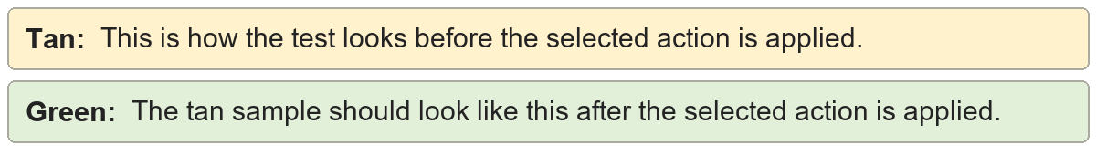
Remove footnotes | The sentence has a footnote reference.
Remove footnotes | The sentence has a footnote reference.

Remove endnotes | The sentence has an endnote reference.
Remove endnotes | The sentence has an endnote reference.

Keep note text inline | The sentence keeps its note.
Keep note text inline | The sentence keeps its note [kept note text].

removable footnote text
kept note text
removable endnote text

